**[](https://www.youtube.com/user/PeteHowellsBooks) Hard Choices**

**Press Release**

For Immediate Release April 2015 (312 Word eBook/Paperback Book Review/Article)

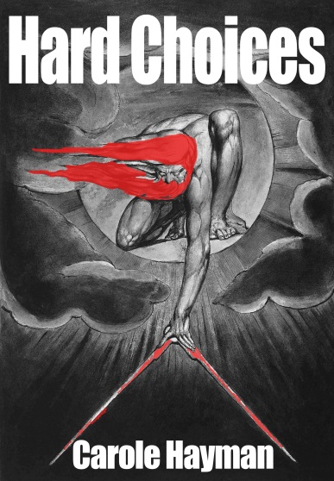

**eBook and paperback**

**Complimentary press copy available on request**

[**pensup.co.uk/contact-us**](http://www.pensup.co.uk/contact-us)

Hard Choices is the book that told the story they didn’t want you to hear. The government, the press and the church have conspired to supress a series of conspiracies.

Grace Fry, MP for Seashoram, is left with the choice; should she join the conspirators or expose the truth?

Will she drink from the poisoned chalice or will politics and ambition get in the way?

**[](https://www.youtube.com/user/PeteHowellsBooks)**

Hard Choices, first published in 2003 by Aurora Press, received critical acclaim from The Express, The Daily Mail and was nominated for several awards. It is being re-released because the truths that were alluded to in this work of fiction seem to have even more resonance in today’s ‘Albion’.

“HARD CHOICES is certainly the kind of satirical fantasy that modern politics can inspire.”

[**Rory Bremner**](http://en.wikipedia.org/wiki/Rory_Bremner)

“This book is both so frightening and such fun; it’s hard to put down. Are contemporary politics really like this? Alas yes.”

[**Fay Weldon**](http://www.fayweldon.co.uk/)

“A hugely funny, futuristic, radical, ripping yarn. A minister speaks her mind, no matter how horrifying the consequences.”

[**Bea Campbell**](http://www.beatrixcampbell.co.uk/)

“I would welcome Grace back into politics at any time.”

[**Lord Ransom MP**](http://www.pensup.co.uk/)

**About the Author**

Carole Hayman is an English writer, broadcaster, actor and director. She was born in Kent, and attended Leeds University and the Bristol Old Vic Theatre School. She was an associate director at The Royal Court Theatre in the late eighties. During that time she appeared in many of Caryl Churchill's plays including, Cloud Nine and Top Girls. As Associate Director, she directed plays by Sarah Daniels, Andrea Dunbar, GE Newman, Fay Weldon and Sue Townsend, including Ripen our Darkness and Byrthrite by Sarah Daniels and Bazaar and Rummage and The Great Celestial Cow by Sue Townsend.

Carole Hayman has published many comic and satirical novels and written radio and TV series for the BBC, ITV and CHANNEL FOUR. These include Ladies of Letters (co-written with Lou Wakefield) and The Refuge and The Spinney (co-written with Sue Townsend).